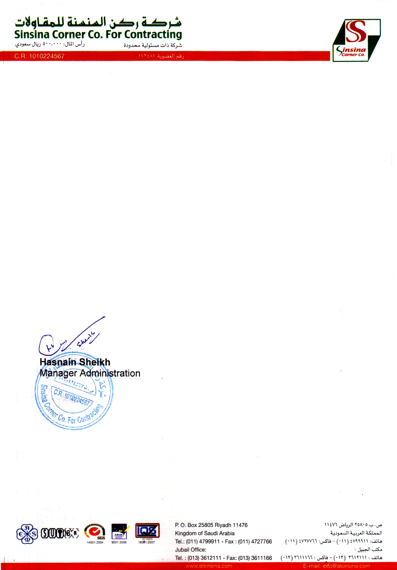

<To2>

**CERTIFICATION**

To WHOM MAY IT CONCERN

This is to certify that Mr. <Name> has been working in our company from <From2> to <To2> to present as a "<Designation>" on our different capacity projects including ABGSD (Aramco schools project) where he was responsible to handle 44 area schools like (Khober, Dhahran, ABQIQ) etc In HVAC plants.

This certificate is being issued for records and references purpose only.

We wish him for very successful future ahead.